Chap 2.2: Session & Cookies

Cookie & Session
Cookie | Session
- Cookie is stored in the hard drive  - Keep information in the user's browser until deleted  - Can store almost anything in a browser cookie  - Less secure – personal information hacked | - Session is stored in browser’s memory  - Session works like a token allowing access and passing information while user’s browsers open  - When user close their browser, sessions are lost  - More secure
- Cookie & session provide much of the same functionality

A. Session Tracking
1. Introduction
- Problem: when clients add an item to their shopping carts (online store), how does the server know what's already in the carts? When clients decide to proceed to checkout, how can the server determine which previously created shopping carts are theirs?
- We need HTTP session tracking because:
  - HTTP is a "stateless" protocol: each time a client retrieves a Web page, the client opens a separate connection to the Web server. The server doesn’t automatically maintain the client’s information
  - There is no built-in support for maintaining contextual information. Even with servers that support persistent (keep-alive) HTTP connections and keep sockets open for multiple client requests

- There are 3 typical solutions to this problem: cookies, URL rewriting, and hidden form fields. All solutions must include the session tracking
Cookie | - You can use cookies to store an ID for a session. With each subsequent connection, you can look up the current session ID use it to extract session’s information  - There are 2 tables: one that associates session IDs, the user tables that store user-specific data  - Need to perform these tasks:  - Extracting the cookie that stores the session identifier from the other cookies  - Determining when idle sessions have expired, and reclaiming them  - Associating the hash tables with each request  - Generating the unique session identifiers
URL Rewriting | - The client appends some extra data on the end of each URL. That data identifies the session the server associates that identifier with user-specific data  - For example: http://host/path/file.html;jsessionid=a1234  - The session identifier: jsessionid=a1234  - a1234 is the ID identifies the user table that store user-specific data  - Advantage: works fine when browsers don't support or disable cookies  - Disadvantage:  - Lots of tedious processing  - URL that references your site & URL that is returned to the user must has the extra data  - Any HTML pages that have a link to your site must be dynamic  - If the user leaves the session and comes back via bookmarks or links from other sites, the session information is lost
Hidden Form Fields | <input type="hidden" name="session" value="a1234">  - When the form is submitted, the session & ID are automatically included in the get or post  - Advantage: works fine when browsers don't support or disable cookies  - Disadvantage:  - Lots of tedious processing  - All pages must be dynamically generated by a form submission

2. Session Tracking Basics
Step 1 – Access the session object:
- Call request.getSession before sending any document to the client
- Syntax 1: HttpSession session = request.getSession() / request.getSession(true)
  - If session already existed return a simple hash table for storing user-specific data
  - If session not already existed create a new one
- Syntax 2: HttpSession session = request.getSession(false)
  - If session already existed return it (a simple hash table for storing user-specific data)
  - If session not already existed return null

Step 2 – Look up information associated with a session:
- Session objects have a built-in hash table that stores keys & values
- Syntax: sessionName.getAttribute(“keyName”)
  - If the value object exists return it cast it to the appropriate type
  - If the value object doesn’t exist return null

Step 3 – Store information in a session:
- Syntax: sessionName.setAttribute(“keyName”, value)

Step 4 – Discarding session data:
- Remove only a specific session data that servlet created: sessionName.removeAttribute("key")
- Delete the whole session: sessionName.invalidate() all user's session data is lost, not just the session data that servlet
- Log the user out and delete all sessions belonging to him or her

//A basic session tracking using request.getSession()/request.getSession(true)
HttpSession session = request.getSession();
SomeClass value = (SomeClass)session.getAttribute("someIdentifier"); //casting
if (value == null) { // No such object already in session
value = new SomeClass(...);
session.setAttribute("someIdentifier", value); //create new session’s data
}
else {
doSomethingWith(value);
}
//A basic session tracking using request.getSession(false)
HttpSession session = request.getSession(false);
if (session == null) {
do something;
} else {
SomeClass value = (SomeClass)session.getAttribute("someIdentifier"); //casting
if (value == null) {
value = new SomeClass(...);
session.setAttribute("someIdentifier", value); //create new session’s data
}
else {
doSomethingWith(value);
}
}

3. Session Tracking Methods
getAttribute() | - Get the previous stored value of the specific attribute in session  - Syntax:  - sessionName.getAttribute(String name)  - request.getSession().getAttribute(String name)  - The output:  - Return a value object need to be casted  - No value return null
getAttributeNames() | - Get the names of all attributes in the session  - Syntax:  - Enumeration names = sessionName.getAttributeNames()  - Enumeration names = request.getSession().getAttributeNames()  - The outputs:  - An enumeration contains attributes’ name  - No attributes return null
setAttribute() | - Set values for attributes or declare a new attribute in the session  - Syntax:  - sessionName.setAttribute(String name, Object value)  - request.getSession().setAttribute(String name, Object value)
removeAttribute() | - Remove values of attributes in the session  - Syntax:  - sessionName.removeAttribute(String name)  - request.getSession().removeAttribute(String name)
invalidate() | - Stop and delete the current session  - Syntax:  - sessionName.invalidate()  - request.getSession().invalidate()
logout() | - Logs the client out of the Web server and invalidates all sessions associated with that client  - Syntax: request.logout()
getId() | - Returns the unique identifier generated for each session  - Syntax:  - sessionName.getId()  - request.getSession().getId()  - Output: a string contains the ID
getCreationTime() | - Returns the time in milliseconds since midnight, January 1, 1970 (GMT) at which the session was first built  - Syntax:  - sessionName.getCreationTime()  - request.getSession().getCreationTime()  - Output: a long value
getLastAccessedTime() | - Returns the time in milliseconds since midnight, January 1, 1970 (GMT) at which the session was last accessed by the client  - Syntax:  - sessionName.getLastAccessedTime()  - request.getSession().getLastAccessedTime()  - Output: a long value
getMaxInactiveInterval()  setMaxInactiveInterval() | - Gets or sets the amount of time session should go without access before being invalidated  - Syntax:  - sessionName.getMaxInactiveInterval()  - request.getSession().getMaxInactiveInterval()  - sessionName.setMaxInactiveInterval(long time)  - request.getSession().setMaxInactiveInterval(long time)
getMaxInactiveInterval()  setMaxInactiveInterval() | Browser Sessions vs. Server Sessions  - By default, session-tracking is based on cookies that are stored in the browser's memory  - At the browser-level: users quit the browser the cookies are broken the browser-session is also broken  - At the server-level: session is maintained when the amount of time between client accesses exceeds the interval specified by getMaxInactiveInterval() automatically become inactive

4. Tracking User’s Data
Immutable data structure | - Immutable = unchangeable. Once it has been initialized, it can’t be changed  - java.lang package wrapper classes (Boolean, Byte, Character, Double, Float, Integer, Long, Short, String)  - Primitive data types (int, short, long, byte, char, float, double, boolean)with:  - "final" keyword  - “private” without setMethod()  - Casting session attribute using immutable data, we must call update the session manually  - The template:  HttpSession session = request.getSession();  ImmutableClass value = ImmutableClass)session.getAttribute("name");  if (value == null) {  value = new ImmutableClass(...);  } else {  Dosomething();  }  session.setAttribute("name", value);
Mutable data structure | - Mutable = changeable  - Arrays  - Collections  - Mutable classes (Date)  - Casting session attribute using mutable data we only internally update what inside that mutable object  - The template:  HttpSession session = request.getSession();  MutableClass value = (MutableClass)session.getAttribute("name");  if (value == null) {  value = new MutableClass(...);  session.setAttribute("name", value);  }  value.updateInternalState(...);  doSomething(value);

//A Servlet That Shows Per-Client Access Counts – use immutable data structure
...solving shoping cart problem…
public class ShowSession extends HttpServlet {
public void doGet(HttpServletRequest request, HttpServletResponse response)
throws ServletException, IOException {
response.setContentType("text/html");
String heading;

HttpSession session = request.getSession();
Integer accessCount =(Integer)session.getAttribute("accessCount");

if (accessCount == null) {
accessCount = new Integer(0);
heading = "Welcome, Newcomer";
} else {
heading = "Welcome Back";
accessCount = new Integer(accessCount.intValue() + 1);
}
session.setAttribute("accessCount", accessCount);

PrintWriter out = response.getWriter();
String title = "Session Tracking Example";
...
...
}
}
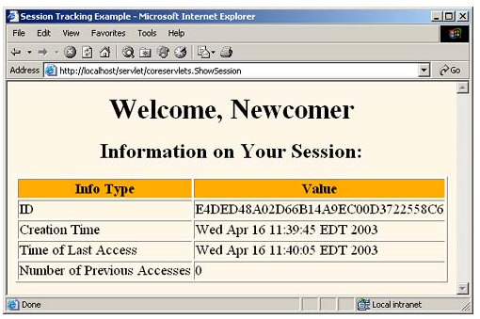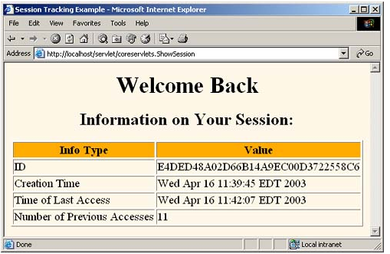
//Use mutable data structures to keep track an attribute that has many values
...
...
public class ShowItems extends HttpServlet {
public void doGet(HttpServletRequest request, HttpServletResponse response)
throws ServletException, IOException {

response.setContentType("text/html");
PrintWriter out = response.getWriter();

HttpSession session = request.getSession();
ArrayList items = (ArrayList)session.getAttribute("previousItems");
if (items == null) {
items = new ArrayList();
session.setAttribute("previousItems", items);
}

String newItem = request.getParameter("newItem");
out.println("<html>");
out.println("<head><title> Items Purchased </title></head>");
out.println("<body>" + "<h1> Items Purchased</h1>");

// synchronized() method will look into the Arraylist and check the objects----------------------
synchronized(items) {
if (newItem != null) {
items.add(newItem);
}
if (items.size() == 0) {
out.println("<i> No items </i>");
} else {
out.println("<ul>");
for(int i=0; i<items.size(); i++) {
out.println("<li>" + (String)items.get(i) + "</li>");
}
out.println("</ul>");
}
//-------------------------------------------------------------------------------
out.println("</body></html>");
}
}
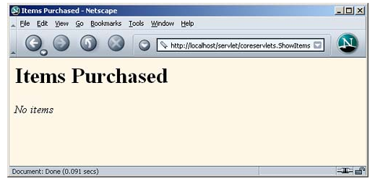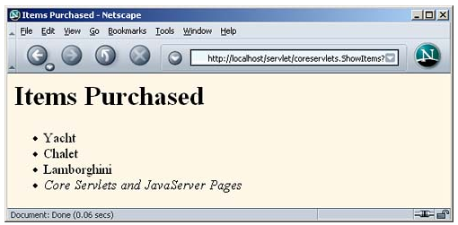

5. Tracking Session Activity
- Use the getCreationTime() and getLastAccessedTime()methods
- We should cast the return value with Date() wrapper class

//The standard way
...
import java.util.Date;
import java.text.DateFormat;
import java.util.Enumeration;

public class SessionDisplay extends HttpServlet {
public void doGet(HttpServletRequest request, HttpServletResponse response)
throws ServletException, java.io.IOException {

response.setContentType("text/html");
java.io.PrintWriter out = response.getWriter();

HttpSession session = request.getSession();
Date creationTime = new Date(session.getCreationTime());
Date lastAccessed = new Date(session.getLastAccessedTime());
Date now = new Date();
DateFormat formatter = DateFormat.getDateTimeInstance(DateFormat.MEDIUM,
DateFormat.MEDIUM);

out.println("<html>");
out.println("<head><title>Tracking Session Activity</title></head>");
out.println("<body>");
out.println("<p>The time now: " + formatter.format(now) + "</p>");
out.println("<p>The creation time:" + formatter.format(creationTime) + "</p>");
out.println("The last accessed time: " + formatter.format(lastAccessed) + "</p>"
out.println("</body>");
out.println("</html>");
}
...
}
//The lazy way
...
...

public class SessionDisplay extends HttpServlet {
public void doGet(HttpServletRequest request, HttpServletResponse response)
throws ServletException, java.io.IOException {

response.setContentType("text/html");
java.io.PrintWriter out = response.getWriter();

out.println("<html>");
out.println("<head><title>Tracking Session Activity</title></head>");
out.println("<body>");
out.println("<p>The time now: " + new Date() + "</p>");
out.println("<p>Creation time:" + new Date(session.getCreationTime())+ "</p>");
out.println("<p>Last accessed time: " + new Date(session.getLastAccessedTime())+
"</p>");
out.println("</body>");
out.println("</html>");
}
...
}

6. URL Writing
- Use the response.encodeURL(String url) method to encode all URLs (used to link with other pages) with the current session ID

// Using URL writing in servlet
...
...
public class UrlRewrite extends HttpServlet {
public void doGet(HttpServletRequest request, HttpServletResponse response)
throws ServletException, java.io.IOException {

response.setContentType("text/html");
PrintWriter out = response.getWriter();
String contextPath = request.getContextPath();
String encodedUrl = response.encodeURL(contextPath + "/default.jsp");
out.println("<html>");
out.println("<head>");
out.println("<title>URL Rewriter</title>");
out.println("</head>");
out.println("<body>");
out.println("<h1>This page will use URL rewriting if necessary</h2>");
out.println("Go to the default.jsp <a href=\"" + encodedUrl + "\">here</a>");
out.println("</body>");
out.println("</html>");
}
⇒ The URL looks like: /home/default.jsp;jsessionid=3CAF7CD0A0BFF5076B390CCD24FD8F0D
// Using URL writing with sendRedirect()
public void doGet(HttpServletRequest request, HttpServletResponse response)
throws ServletException, java.io.IOException {

//redirect the user depending on the value of the “go” parameter
String destination = request.getParameter("go");
String contextPath = request.getContextPath();

if(destination == null || destination.equals(""))
throw new ServletException("Missing or invalid 'go' parameter in " +
getClass().getName());

if(destination.equals("weather")){
response.sendRedirect( response.encodeRedirectURL(contextPath + "/weather"));
}

if(destination.equals("maps")){
response.sendRedirect( response.encodeRedirectURL(contextPath + "/maps"));
}
}

B. Cookies

1. Benefits of Cookies
- Identifying a User during an E-commerce Session. "Shopping online" website many users select many items and add them to their shopping carts, then continue shopping. The cookie remembers which user selects which item
- Remembering Usernames and Passwords. Log in to a site automatically (convenience for users of unshared computers)
- Customizing sites. Some sites allow user to customize the look of the main page, how search results should be displayed,….These user preferences can be stored in cookies
- Focusing advertising. Cookies let the site remember which topics interest certain users and show advertisements relevant to those interests

2 Some Problems with Cookies
- The problem is privacy, not security
  - Servers can remember your previous actions. If you give out personal information, servers can link that information to your previous actions
  - Servers can share cookie information through use of a cooperating third party like
  - Poorly designed sites store sensitive information like credit card numbers directly in cookie
  - JavaScript bugs let hostile sites steal cookies (old browsers)
- Moral for servlet authors:
  - If cookies are not critical to your task, avoid servlets that totally fail when cookies are disabled
  - Don't put sensitive info in cookies

3. Sending and Receiving Cookies
3.1 Sending cookies to the client involves 3 steps:
- Create a Cookie object: Cookie cookie = new Cookie("name", "value");
  - Call the Cookie constructor
  - The “name” & the “value” = string without white space or [ ] ( ) = , " / ? @ : ;
- Setting the maximum age: cookie.setMaxAge(60*60*24*7); // = 1 week
  - A default cookie = session-level cookie, which is stored in the browser's memory and deleted when the user quits the browser
  - The time unit in setMaxAge() = seconds
- Placing the Cookie in the Response Headers: response.addCookie(userCookie);
  - If you don't send the cookie to the client, it has no effect

3.2 Reading cookies from browser involve 2 steps:

Call request.getCookies()
  - If the request contains cookies returns an array of Cookie objects corresponding to the “value”
  - If the request contains no cookies return null or zero-length array

Loop Down the Cookie Array
  - Calling getName() to get the cookies’ names
  - Calling getValue()to get the cookies’ values

Cookie[] cookies = request.getCookies();
if (cookies != null) {
for(int i=0; i<cookies.length; i++) {
Cookie cookie = cookies[i];
if (cookie.getName().equals(“some name”)) {
doSomethingWith(cookie.getValue());
}
}
}

//Setting cookies & send them to the client browser
package servlet;
import javax.servlet.*;
import javax.servlet.http.*;

public class CookieServlet extends HttpServlet {
public void doGet(HttpServletRequest request, HttpServletResponse response) throws
ServletException, java.io.IOException {

//Get an array of Cookies associated with this domain
Cookie cookie = null;
Cookie[] c = request.getCookies();
boolean isNew = false;

if (c != null){
for (int i = 0; i < c.length; i++){
if (cookies[i].getName().equals("Long")){
cookie = c[i];
}
}
}
else {
isNew=true;
int maxAge;
try{
maxAge = new Integer(getServletContext().getInitParameter(
"cookie-age")).intValue( );
} catch (Exception e) {
maxAge = -1;
}
//Create the Cookie object
cookie = new Cookie("mycookie",""+getNextCookieValue());
cookie.setPath(request.getContextPath());
cookie.setMaxAge(maxAge);
response.addCookie(cookie);
}

//Get some info about the cookie
response.setContentType("text/html");
java.io.PrintWriter out = response.getWriter();
out.println("<html>");
out.println("<head>");
out.println("<title>Cookie info</title>");
out.println("</head>");
out.println("<body>");

out.println("<h2> Information about the cookie named \"mycookie\"</h2>");
out.println("Cookie value: "+cookie.getValue( )+"<br>");
if (newCookie){
out.println("Cookie Max-Age: "+cookie.getMaxAge( )+"<br>");
out.println("Cookie Path: "+cookie.getPath( )+"<br>");
}

out.println("</body></html");
}

public void doPost(HttpServletRequest request,
HttpServletResponse response) throws ServletException, java.io.IOException {
doGet(request,response);
}
}
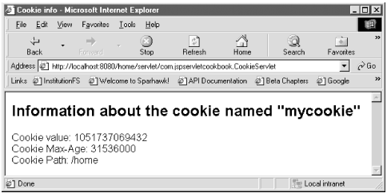
//Reading cookies
package servlet;
import javax.servlet.*;
import javax.servlet.http.*;

public class CookieReader extends HttpServlet {
public void doGet(HttpServletRequest request, HttpServletResponse response) throws
ServletException, java.io.IOException {

Cookie cookie = null;
Cookie[] c = request.getCookies();
boolean isNew = false;

if (c != null){
hasCookies = true;
}

// display the name/value of each cookie
response.setContentType("text/html");
java.io.PrintWriter out = response.getWriter();

out.println("<html>");
out.println("<head>");
out.println("<title>Cookie information</title>");
out.println("</head>");
out.println("<body>");

if (isNew){
out.println("<h2> The name and value of each found cookie</h2>");

for (int i = 0; i < c.length; i++){
cookie = c[i];
out.println("Name of cookie "+(i + 1)+": "+ cookie.getName()+"<br>");
out.println("Value of cookie "+(i + 1)+": "+ cookie.getValue()
+"<br><br>");
}
} else {
out.println("<h2> This request did not include any cookies</h2>");
}
out.println("</body>");
out.println("</html>");
}

public void doPost(HttpServletRequest request, HttpServletResponse response) throws
ServletException, java.io.IOException {
doGet(request,response);
}
}
4. Session Cookie vs Persistent Cookie
...
...
public class CookieTest extends HttpServlet {
public void doGet(HttpServletRequest request, HttpServletResponse response)
throws ServletException, IOException {

for(int i=0; i<3; i++) {
// Default maxAge is -1, indicating cookie applies only to current browsing session.
Cookie cookie = new Cookie("Session-Cookie-" + i, "Cookie-Value-S" + i);
response.addCookie(cookie);

// Cookie is valid for an hour, regardless of whether
// user quits browser, reboots computer, or whatever.
cookie = new Cookie("Persistent-Cookie-" + i, "Cookie-Value-P" + i);
cookie.setMaxAge(3600);
response.addCookie(cookie);
}

response.setContentType("text/html");
PrintWriter out = response.getWriter();
out.println("<html>");
...
...

Cookie[] cookies = request.getCookies();
if (cookies == null) {
out.println("<tr><th colspan=2 >No cookies");
} else {
Cookie cookie;
for(int i=0; i<cookies.length; i++) {
cookie = cookies[i];
out.println("<tr><td>" + cookie.getName() + "</td>")
out.println("<td>" + cookie.getValue() + "</td></tr>")
}
}
out.println("</table></body></html>");
}
}
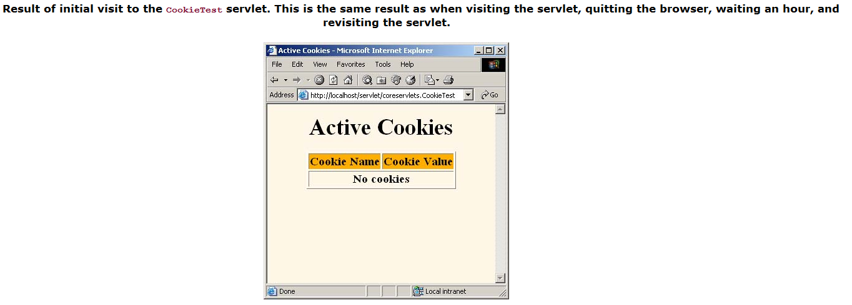
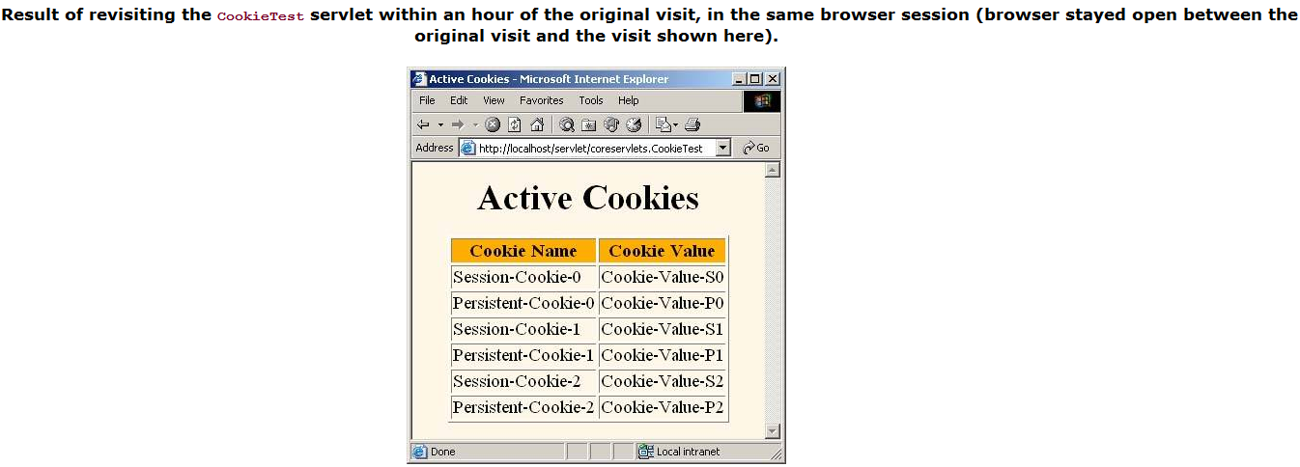
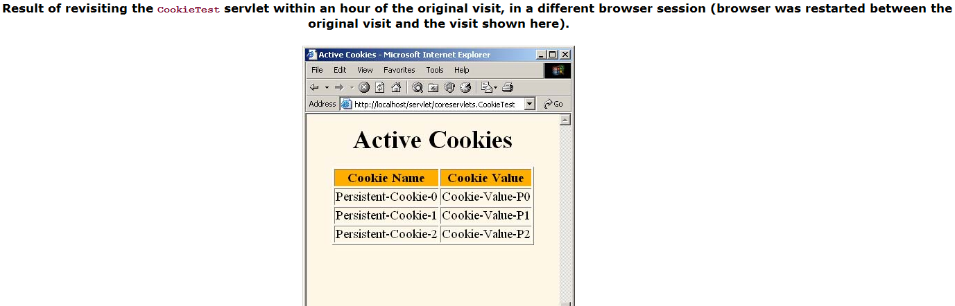

5. Some Application with Cookies
// Detect First-Time Visitors
boolean isNew = true;
Cookie[] cookies = request.getCookies();
if (cookies != null) {
for(int i=0; i<cookies.length; i++) {
Cookie c = cookies[i];
if((c.getName().equals("repeatVisitor")) && (c.getValue().equals("yes"))) {
isNew = false;
break;
}
}
}
String title;
if (isNew) {
Cookie returnVisitorCookie = new Cookie("repeatVisitor", "yes");
returnVisitorCookie.setMaxAge(60*60*24*365);
response.addCookie(returnVisitorCookie);
title = "Welcome Aboard";
} else {
title = "Welcome Back";
}
//Couting the access time
...
...

protected void processRequest(HttpServletRequest request, HttpServletResponse response)
throws ServletException, IOException {
response.setContentType("text/html;charset=UTF-8");
PrintWriter out = response.getWriter();

String title = "";
int temp = 0;
Cookie c[] = request.getCookies();
if (c != null) {
for (int i = 0; i < c.length; i++) {
if (c[i].getName().equals("count")) {
title = "Welcome Back";
temp = Integer.parseInt(c[i].getValue()) + 1;
c[i].setValue(toString().valueOf(temp));
c[i].setMaxAge(3600);
response.addCookie(c[i]);
}
}
} else {
title = "Welcome Abroad";
Cookie cookie = new Cookie("count", "0");
cookie.setMaxAge(3600);
response.addCookie(cookie);
}
out.println("<html>");
out.println("<head>");
out.println("<title>Access Counts</title>");
out.println("</head>");
out.println("<body>");
out.println("<h1 align=center>" + title + "</h1>");
out.println("<p align=center>Counts: " + temp + "</p>");
out.println("</body>");
out.println("</html>");
}

